REPORT OF SOLOMON ISLANDS

CRIMINAL JUSTICE SYSTEM

COMPILED BY: FLORENCE JOEL
PROSECUTOR

KOICA TRAINING CENTRE
KOREA
DATE: 15/06/2008

BACKGROUND OF SOLOMON ISLANDS
Map of Solomon Islands
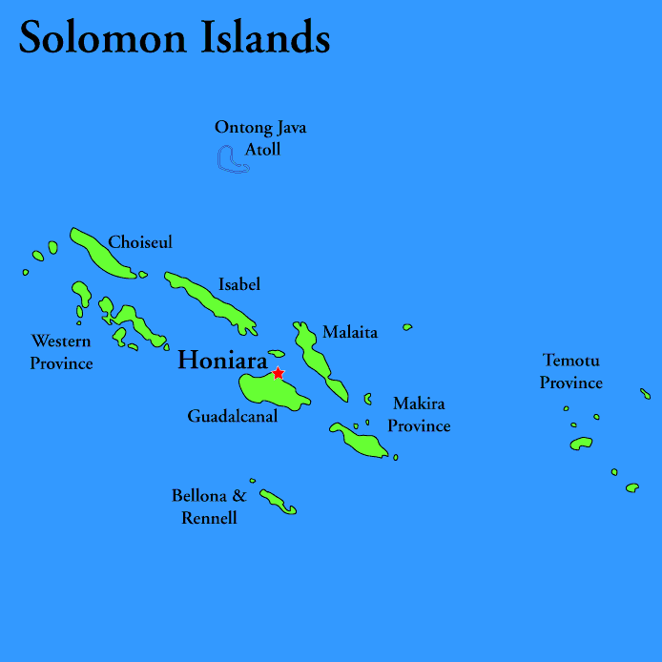

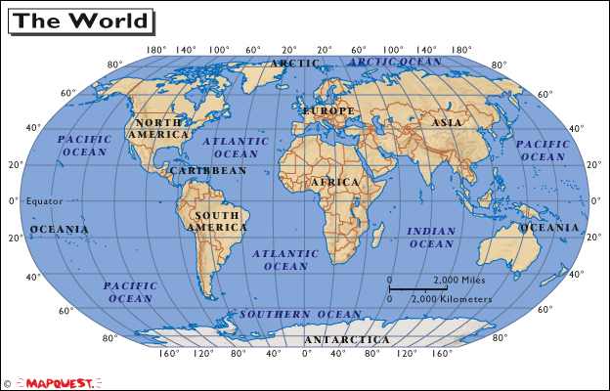

The Solomon Islands is a nation which is located east of Papua New Guinea in the Southern region of the Pacific Ocean. It consists of nearly one thousand islands. However, out of those many islands there are six main big islands. The capital is Honiara and it is located on one of those big islands called Guadalcanal. The land mass is 28,400 square kilometres (10,965 sq mi).
The population of Solomon Islands is about 552,438. Ninety percent of Solomon Islanders are professed Christians. The five main Christian churches are the Catholic, Anglican, South Sea Evangelical, Seventh Day Adventist, and Christian Fellowship (a derivative of Methodism). Beside Christians, there are traditional practitioners, Mormons, Muslims, and Baha'is.
The official language is English and pidgin. Apart from that, there are about 64 languages spoken by people in the country.
The people in the Solomon Islands are made up of three different races. The large group is made up of the Melanesian race and the others are Polynesian and Micronesian.

The United Kingdom established a protectorate over the Solomon Islands in the 1890s. Some of the most bitter fighting of World War II occurred in the Solomon Islands campaign of 1942–45, including the Battle of Guadalcanal.
Self-government was achieved in 1976 and it gained independence two years later in 1978. The country is a Commonwealth realm.
In 1998 to 2003 ethnic crises broke out in the Solomon Islands and it undermines the criminal justice system of Solomon Islands because people took laws into their own hands. In 2003 Regional Assistance Mission to Solomon Islands consisting of the South Pacific countries intervene to restore law and order.
The Solomon Islands are a constitutional monarchy and have a parliamentary system of government. Queen Elizabeth II is the Monarch of the Solomon Islands and the head of the State. She is represented by the Governor –General who is chosen by the Parliament for a five-year term.
The head of government is the Prime Minister, who is elected by Parliament and chooses the other members of the cabinet. Each ministry is headed by a cabinet member, who is assisted by a permanent, a career public servant, who directs the staff of the ministry. It is a democratic country.
The government has three arms. They are the Legislator, Executive and the Judiciary. They perform their functions independently from each other.

INTRODUCTION
The Criminal justice system in the Solomon Islands (SI) is akin to the system in most other South Pacific countries. It adopts the common law system. The Constitution of Solomon Islands provides for the establishments of the Courts and the Judges which is set up under the Judiciary arm of the government. It follows the adversarial system.
Our Criminal justice system has received a boost since the arrival of The Regional Assistance Mission to the Solomon Islands (RAMSI) in 2003 and the large presence of expatriate lawyers mainly from Australia to help restore law and order. The presence of expatriate Advisors in every area of the Criminal justice system has improved the system and made it more functional and time conserving.
The Criminal Justice system is mainly comprised of the following institutions.
- COURTS

- PUBLIC PROSECUTION (DIRECTOR OF PUBLIC PROSECUTIONS OFFICE AND POLICE PROSECUTION)

- LEGAL AID (PUBLIC SOLICITORS OFFICE)

- POLICE

- PRISON SERVICE

The main laws that involve the criminal justice system are as follows:

- Constitution of Solomon Islands 1978

- Penal Code [Cap 26] 1990

- Criminal Procedure Code [Cap 7]

- Evidence Act of UK

- Magistrate Court Act [Cap 20]

- Prisons Act [ Cap 111]

- Police Act [ Cap 110]
There are many more but these are the main ones.

Court of Appeal

High Court

Magistrate Court

Legal Aid (Public Defender)
Prosecution (DPP)

Prison Service

Police Investigation

Commission of Crime

COURTS
MAGISTRATE COURT
The Magistrates court is established by virtue of section 3 of the Magistrates’ Court Act [CAP 20]. This Court is headed by the Chief Magistrate, whose function is more administrative rather than presiding over cases. He/she assigns cases to other Magistrates and ensures the day to day efficient running of the Magistracy. He is supported by other Principal and Lay Magistrates. The Chief Magistrate is appointed by the Governor General on the advice of the Judicial Legal Service Commission (JLSC). The other Magistrates are appointed by the Judicial Legal Service Commission.
The Magistrates Court is a court of summary jurisdiction. They deal with minor and semi serious offences, or matters that do not require a great deal of legal issues. The Magistrates Court also has jurisdiction to conduct preliminary enquiries to determine whether there is sufficient evidence in any case for it to be committed to the High court. Magistrates have jurisdiction to try any criminal offence for which the maximum punishment prescribed by law for such offence does not exceed 14 years. The maximum punishment which the Principal Magistrate Court may impose shall not exceed a term of imprisonment of five years and a fine of $1,000.00 or both such imprisonment and such fine.
There is a Magistrates Court Act (Cap 20) which sets out the powers and functions of Magistrates. That Act was last reviewed in 1996.
There are a number of expatriate Magistrates supported by RAMSI Law and Justice Programs. Apart from presiding over the more difficult and the tension cases they also capacity build local magistrates.
HIGH COURT
The High Court of Solomon Islands (the judiciary) is headed by the Chief Justice and supported by Puisne judges. It has unlimited jurisdiction and deals mostly with serious and all tension matters which arose from the ethnic tension between 1999- 2003.
A number of Puisne Judges are expatriates who are supported by RAMSI Law and Justice Program. They were particularly recruited to preside over tension matters and capacity build local judges.
The High court is a court of first instance as well as an appellate court having jurisdiction to hear appeals from the Magistrates courts.
The judge sits as the trier of fact and trier of law. We have no jury system.
The Chief Justice and the Puisne judges are appointed by the Governor General acting in accordance with the advice of the Judicial Legal Service Commission. A person is qualified to be a judge if he holds or held high judicial office in any country in the commonwealth or any country outside the commonwealth that may be prescribed by the parliament. Also he must be qualified to practice as barristers and solicitors in such country and he has been qualified for not less than five years.

COURT OF APPEAL
The Court of Appeal is presided over by expatriate judges and is convened 2 to 3 times a year to determine all criminal matters on appeal. It is purely an appellate court and hears appeals from the high court as well as second appeals from Magistrates courts. It has wide powers and is governed by the Court of Appeal Act, Cap 6. The judges of the Court of Appeal shall be the President of the Court of Appeal and other justices. They are appointed by the Governor General in the advice of the Judicial Legal Service Commission.
THE DIRECTOR OF PUBLIC PROSECUTIONS, HIS ROLE AND OFFICE
There is a Director of Public Prosecution (DPP) as well as a Deputy Director. The Director’s post is established under s 91 of the Constitution of Solomon Islands. The position of the Deputy Director is currently vacant due to inability to attract an appropriate person under the government salary structure.
There are 15 established positions of Crown Counsel in the office of the Director of Public Prosecution but only 7 positions are currently occupied again because of the non attractive remuneration offered to government lawyers. Since 2003 RAMSI has provided a good number of Advisors to undertake tension matters as well as capacity build local lawyers.
The Director of Public Prosecution is appointed by the Governor General acting in accordance with the advice of the Judicial Legal Service Commission. The Prosecutors are appointed by the Judicial Legal Service Commission.
The functions of the DPP according to section 91 of the Constitution are to:-
- Institute criminal proceedings against persons
- Takeover or continue any criminal proceedings
- Discontinue criminal proceedings at any stage before judgment is delivered at any criminal proceedings instituted
- Exercise his powers without directions or control of any person or authority
- In exercising of his function he is not subject to the direction or control of any person or authority except on the matters of international relations or matter relating to national security of Solomon islands
Prosecutors
The functions of each prosecutor are:
- Each prosecutor appointed represents the Crown in every criminal proceedings at any Court
- Gives advice to Police investigators
- Gives lectures to the Police Academy on matters relating to criminal Law.

PUBLIC SOLICITORS OFFICE
The office of Public Solicitors office is headed by the Director of Public Solicitor who is supported by many Public Solicitors both local and RAMSI Advisors. The post of Public Solicitor is a constitutional post established under s92 of the Constitution of Solomon Islands. The Director of Public Solicitor is appointed by the Governor General acting in accordance of the advice of the Judicial Legal Service Commission
The functions of the Public solicitor are to:
- To provide legal aid, advice and assistance to person who is in need who is charged with criminal offence
- To provide legal, advice and assistance to any person as directed by the High Court
- To defend accused in court
POLICE
When a crime is being committed, the police will do the investigation and arrest the person accused of the crime.
After they compiled all the evidences they sent the file to the Office of the Director of Public Prosecution for review. On the conclusion of the investigation the DPP elects charges. The matter is given to the Prosecution to prosecute in Court. If the offence is less serious such as traffic offences, drunk and disorder in public places etc the Police Prosecution will prosecute those types of cases. The serious crimes such as murder, rape, incest etc are prosecuted by the Director of Public Prosecution.
Police officers also have the power according to Police Act to make a complaint or charge against any person before a Magistrate and to apply for a summons, warrant, search warrant or such other legal process as may by law issue against any person.
The office of the Police is established by the Police Act [CAP 110]. It is headed by the Police Commissioner.
PRISON SERVICE /CORRECTIONAL INSTITUTE
When the accused is found guilty he will be punished. He is either sentenced to imprisonment or paying of fines. When he is sentenced to imprisonment then he is put in prison. The prison service looks after the prisoners. They allocate prisoners to any prison; and classify prisoners according to classifications specified by regulations made from time to time under section 1 of the Prison Act. We have no death penalty. The maximum punishment is life time imprisonment.

The prison service is established by the Prison Act [Cap 111]. The Prison service and police had one Commissioner which is called the Commissioner of Police and prison service.

LEVEL OF LEGAL PRACTICE IN OUR CRIMINAL JURISDICTION
The presence of RAMSI and expatriate lawyers has positively affected the level of legal practitioner within our criminal justice system. The level of practice ensures adequate legal representation, the protection of the rights of accused persons. Everyone accused of a crime is entitled to legal representation irrespective of their status or economic means.
THE CONSTITUTION
The constitution of Solomon Islands enshrines the rights of persons who are charged with offences. Such rights include the right to be informed, legal representation, trial within a reasonable time, presumption of innocence, presumption in favor of bail, provision of an interpreter etc (section 10)
The Constitution establishes the positions of the Chief Justice, Puisne judges, the DPP, PSO and other functions of the criminal justice system.
Lawyers in Government establishments.
It has been difficult to attract lawyers to the High Court Bench, Magistracy, Public Solicitor’s Office and particularly the Office of the Director of Public Prosecutions because of remuneration and conditions of service provided by the government. The package is unattractive.
A number of qualified lawyers have left the country to work overseas or in private practice. This matter is of great concern to many people and particularly the Chief Justice. He is presently consulting with RAMSI through the Minister for Justice. He has advocated for RAMSI’s support in terms of topping up the salaries of lawyers engaged in public service rather than the provisions of many expatriate lawyers.
Trials.
Solomon Island is a common law jurisdiction. Trials are conducted in open court in the English language which is interpreted to an accused in his own language. The accused person is given all opportunity to cross examine witnesses called by the crown, to call his own witnesses and is given adequate legal representation. Trial times are reasonable and decisions often delivered within a reasonable time.
Everyone convicted of a crime has a right to appeal against both his conviction and sentence to the next higher court, as well as second appeal to the Court of Appeal.
An appellant is entitled to the records of the lower court’s proceedings at no cost and is entitled to legal representation on appeal.

REFORM PLANS
The Penal Code (Cap 26) and Criminal Procedure Code (Cap 7) laws of Solomon Islands are quite old and out dated and have not been modified significantly since the exit of the colonial administration. There has never been an Evidence Act in Solomon Islands.
A Law Reform Commission has been established; it has recently been strengthen in terms of man power and is now working tirelessly towards the review of these legislations and others. There are plans to review the Penal Code and the Criminal Procedure Codes. Preliminary work of consultation with Stakeholder has already begun.
RAMSI Law and Justice Program has assisted the reform process through the provision of experts in the area of law reform. These experts are currently reviewing old legislations and drafting new ones. A new Evidence Bill has recently been drafted and circulated to stakeholders who are now considering the Bill. The Young Persons Act has been reviewed partially as a result of the increasing presence of young offenders within the Criminal justice system.

CONCLUSION
There is now a general awareness that the criminal laws of Solomon Islands are outdated and out of touch with developments around the world. It is good to see the efforts being made in the review of these laws. While it may take a long time to accomplish the review process it is certain that the reviews will be accomplished at some time. These will enhance the Criminal justice system in the country so that justice will be best served.

The Role and Functions of Related Authorities in Charge of Corruption Prevention (ex. Court. Police, Prosecutors)

Introduction
For a long time in Solomon Islands corruption has been prevalent at all levels of government and private establishments. No one or organization paid any attention to the situation. It was like a cancer eating deep into every fabric of society.
In 2003 when RAMSI arrived the country, attention was drawn to this evil within our society and for the first time serious steps were devised and are now being implemented to stop the spread of this cancer. Anti-corruption institutions were set up.
Government establishments
RAMSI has posted expatriates personnel to strategic places (such as immigration, Revenue customs, shipping, finance and other government departments) to advise and supervise local personnel in charge of financial regulations and accounting. The reason for such postings of expatriates is to strengthen those organizations, departments and authorities, such that they will be more effective in their roles either as collection agents, policy makers and executors of government policies.
Ombudsman’s office
The Ombudsman’s office is a public office which is established by the Constitution under s 96 to investigate corruption or misconduct by the Ministers of the Government and make recommendations. Their main functions in combating corruption are to:
1. enquire into the conduct of any person in the exercise of his office or authority, or abuse thereof;
2. assist in the improvement of the practices and procedures of public bodies; and
3. ensure the elimination of arbitrary and unfair decisions.
Courts
The courts have been strengthened through the provision of expatriates magistrates and judges specifically dedicated to preside over corruption matters.
The DPP AND PSO offices
RAMSI has allocated expatriate lawyers to both offices specifically assigned to deal with corruption cases. To render legal opinions as well as prosecute and defend corruption matters and cases.
Police
RAMSI has provided large number of advisors from Australia, New Zealand, Fiji, Tonga and other South Pacific countries to capacity build local police officers in the area of investigations of corruption cases as well to train local police prosecutors to effectively prosecute corruption cases.

Conclusion
Therefore, there are lots of strategic plans put through the establishment of anti-corruption institutions to prevent corruption. We hope that relevant authorities in charge of combating corruption will work hard to reduce the level of corruption which contributes in the fall of our country in the past years.

May God Bless the Solomon Islands

Thank you.

